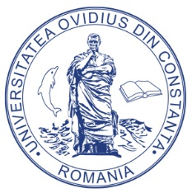
MINISTERUL EDUCAŢIEI NAŢIONALE

UNIVERSITATEA „OVIDIUS” DIN CONSTANŢA
Bd. Mamaia nr. 124, 900527 Constanța, România
Tel./Fax: +4 0241 606407, +4 0241 606467
E-mail: rectorat2@univ-ovidius.ro,
Web page: www.univ-ovidius.ro

APPLICATION FORM
- BASKETBALL
MALE |  |  | PLAYERS |  |  | FEMALE
1 |  |  |  | 5
2 |  |  |  | 6
3 |  |  |  | 7
4 |  |  |  | 8
TRAINER
1

- VOLLEYBALL FEMALE
PLAYERS
1 |  | 6
2 |  | 7
3 |  | 8
4 |  | 9
5
TRAINER
1

- HANDBALL FEMALE
PLAYERS
1 |  | 6
2 |  | 7
3 |  | 8
4 |  | 9
5
TRAINER
1

- SWIMMING
MALE |  |  | PLAYERS |  |  | FEMALE
1 |  |  |  | 1
2 |  |  |  | 2
TRAINER
1

- TENNIS
MALE |  |  | PLAYERS |  |  | FEMALE
1 |  |  |  | 1
2 |  |  |  | 2
TRAINER
1

- TABLE TENNIS
MALE |  |  | PLAYERS |  |  | FEMALE
1 |  |  |  | 1
2 |  |  |  | 2
TRAINER
1

- LOW-LEVEL FOOTBALL MALE
PLAYERS
1 |  | 5
2 |  | 6
3 |  | 7
4 |  | 8
TRAINER
1

HEAD OF DELEGATION
MEMBERS
1
2

